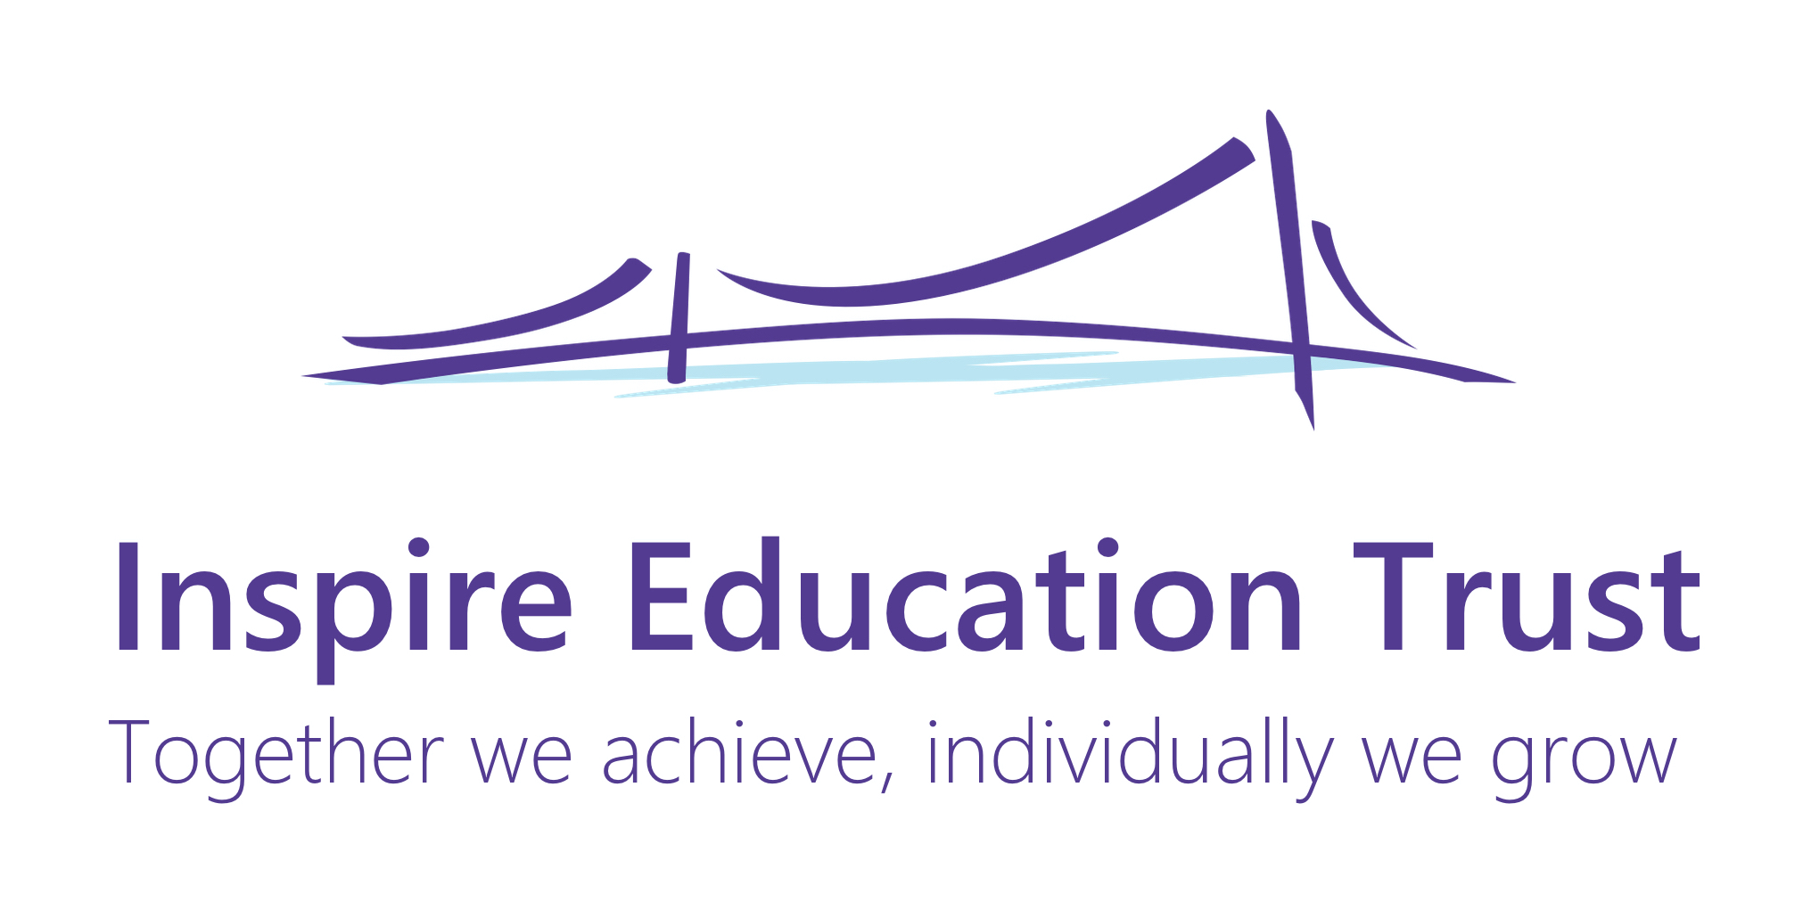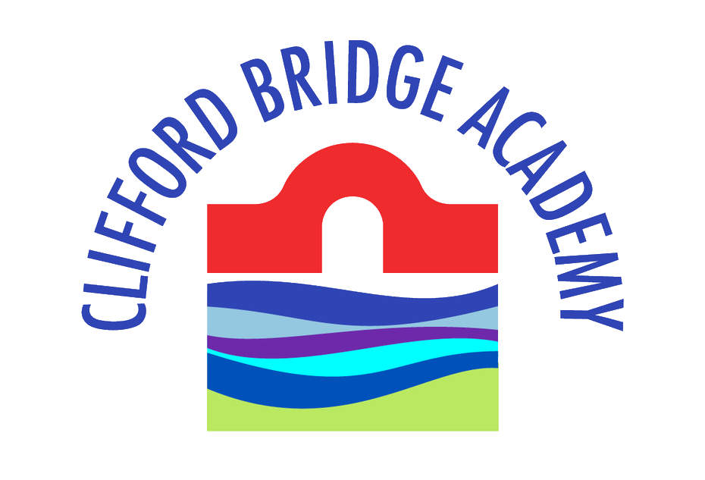

**Year 6 Curriculum Letter - Spring 2023**

Dear Parents & Carers,

Welcome back from the Year 6 Team! We hope that you and your family had an enjoyable Christmas and New Year. This letter is to keep you informed about some of the work that the children will be doing during the spring term.

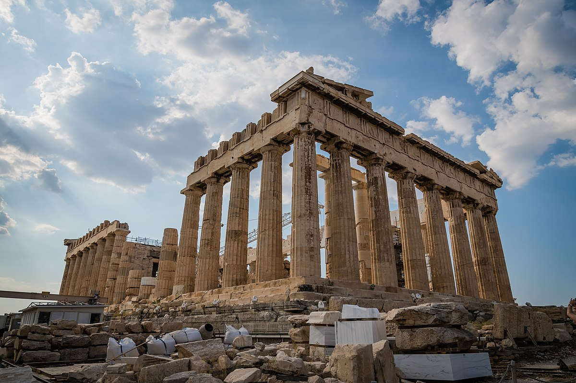**Theme – Greek Legacy**

This Term our topic is ‘Greek Legacy’. Within this theme, the children will be learning about Ancient Greece. They will be exploring artefacts and discover all about Ancient Greek art and culture, producing music for the Olympic Games using music technology, sculpting a Greek vase and sewing a Greek-inspired cushion with their own fabric printing design. We hope that the children are as excited about the theme as we are! Be sure to ask them about the topic as it progresses.

**English**

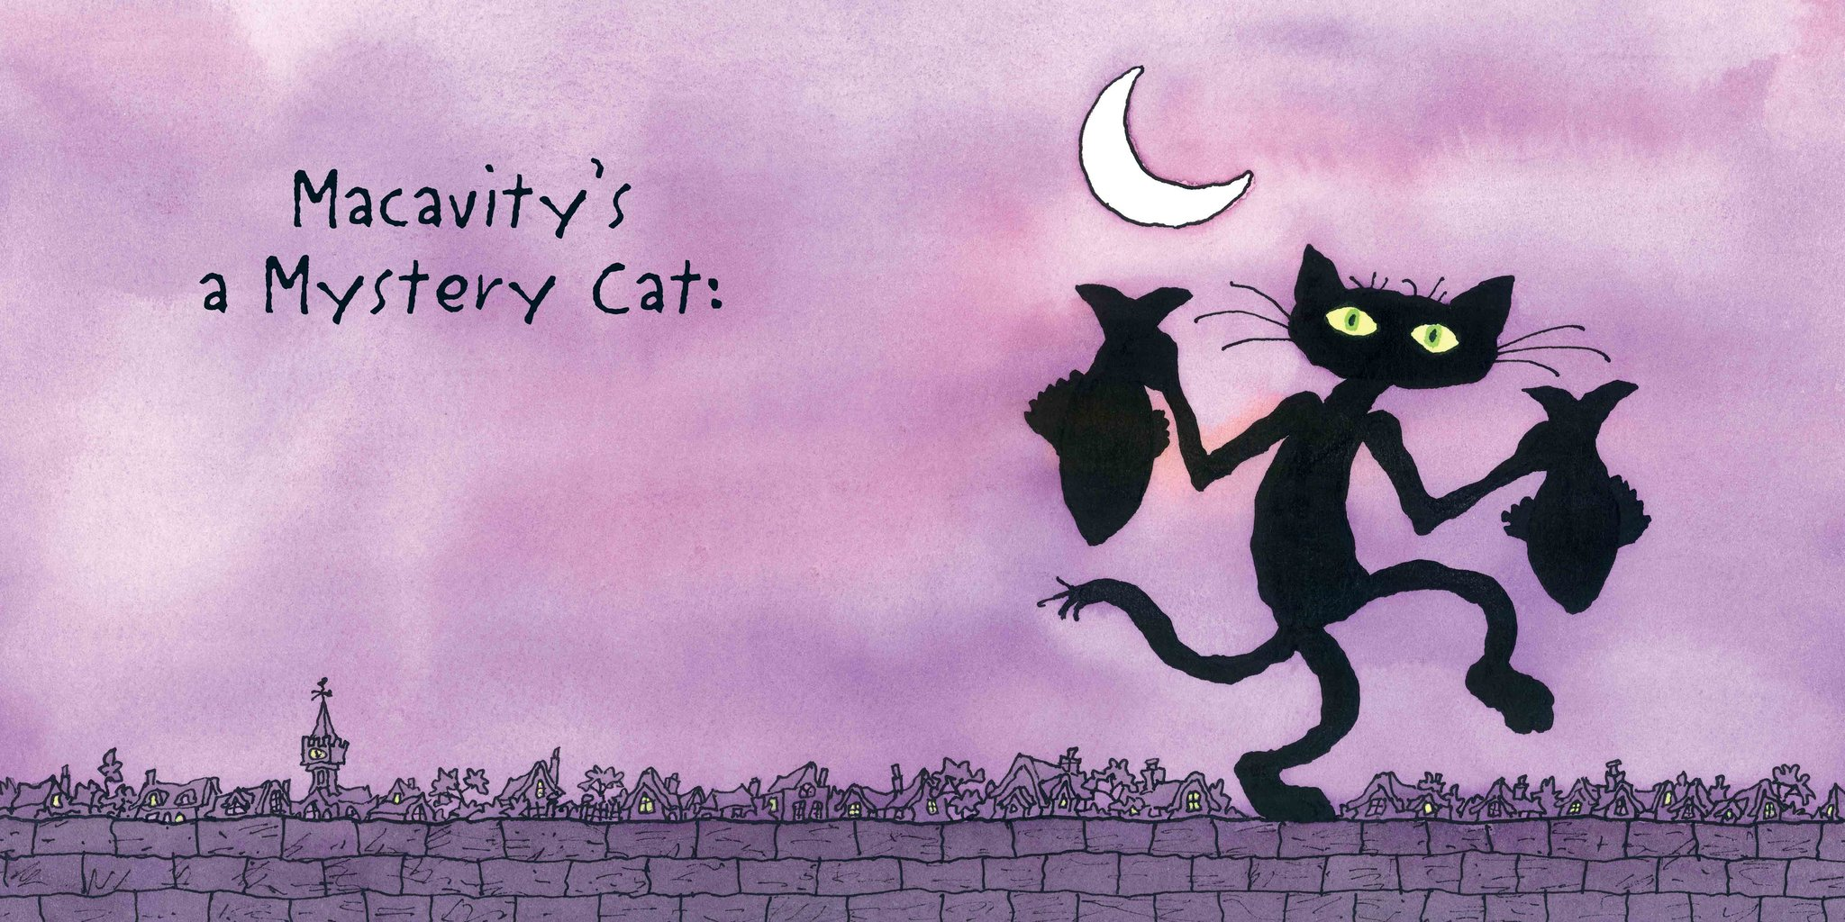During this term, the children will continue to engage with a range of fantastic narrative and poetic texts. They will continue to develop their reading skills, by inferring and deducing answers to questions about what they have read in greater depth. To start the term, they will be immersing themselves in the class poem, Macavity: The Mystery Cat by TS Eliot. The children will be creating their own character description of Macavity for social media – keep an eye out! In their narrative work, children will be focusing on writing from different characters’ perspectives, using ‘Macbeth’ by William Shakespeare as their text base. As part of this Traditional Tale unit, they will also be writing a newspaper article based on an event from Macbeth. With ‘Stormbreaker’ by Anthony Horowitz as our stimulus, Year 6 will be becoming spies! Using this book as inspiration, they will be writing a persuasive letter applying for the job of a spy which will be sent to MI5 and GCHQ before finally writing their own suspense story for the main character, Alex Rider. The children will continue to write at greater length with increasing accuracy and appropriate detail across a variety of genres. Their understanding of grammar and punctuation will continue to develop as they build on their work from previous years.

**Mathematics**

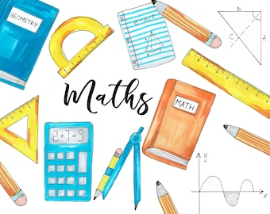During this term, the children will be focusing on securing their understanding of the four operations whilst recapping the skills taught and areas covered within the Maths curriculum in Key Stage 2. During the first two weeks, we will concentrate on securing arithmetic knowledge and understanding of place value. We will move on to finding percentages of amounts, finding the perimeter and area of different shapes, angles, volume and graphs. We will be introducing ratio and averages this term where they will be able to find and compare quantities from ratios. As always in Year 6, children’s knowledge of their times tables up to 12 x 12 is extremely important. This allows them to quickly recall key number facts as well as giving a clear platform to be able to use and apply their number skills within the context of problem solving. We will continue to recap key parts of the Maths curriculum during Active Maths, mental orals and our weekly arithmetic sessions.

**Science**

This term in Year 5 Science, children will be covering the following units:

- **Danger Low Voltage**

During this topic, the children will learn all about electricity and how it is conducted or insulated. The children will compare and give reasons for variations in how components function, including the brightness of bulbs, the loudness of buzzers and the on/off position of switches. They will also use recognised symbols when representing a simple circuit in a diagram.

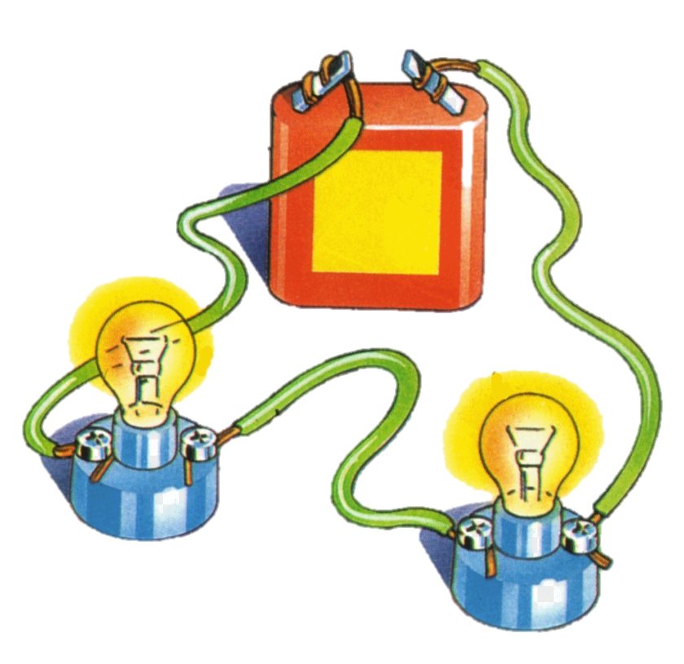- **Body Pump**

During this topic, the children will learn all about the main parts of the human circulatory system. They will be able to describe the function of the heart, blood vessels and blood. In addition, they will spend time recognising the impact of diet, exercise and lifestyle on the way their bodies function. They will also be able to describe the ways in which nutrients and water are transported within animals Including humans.

**Personal, Social and Health Education - PSHE**

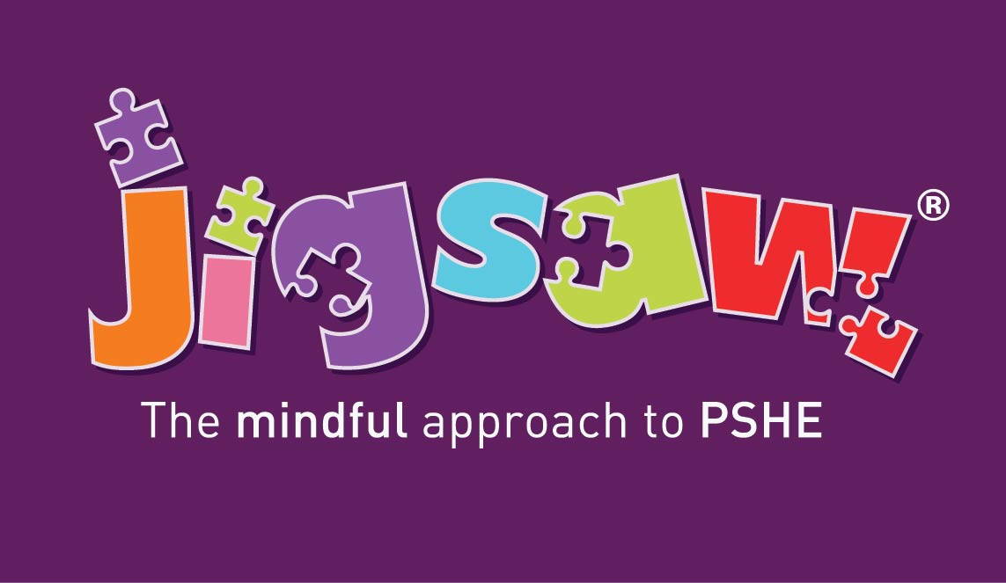Our Jigsaw themes this term are ‘Dreams and Goals’ and ‘Healthy Me’. Children will be thinking about: personal and academic goals and targets; aspirations and dreams for the future; the importance of living a healthy and active lifestyle, and body image and personal health. We will continue having weekly Thrive class assemblies, that will support the children’s emotional health, well-being and social skills. This allows the children to develop their voice in order to express their needs and feelings.

**Physical Education - PE**

In PE, we will be focusing on Dance, Tag Rugby, Gymnastics and Basketball. These will take place on Tuesdays

(indoor) and Fridays (indoor). You may even spot some of our dance routines in our end of year production! Children should wear their PE kit to school on these days to maximise learning time. Just a reminder that children are required to wear a white t-shirt and dark coloured shorts, leggings or tracksuit bottoms. Children should have their red school jumper, cardigan or fleece over the top of their PE t-shirt. Earrings must be taken out or covered and as in school, long hair must be tied back. Please support this vital area of the curriculum by helping children to bring the correct changes of clothes to school for these sessions.

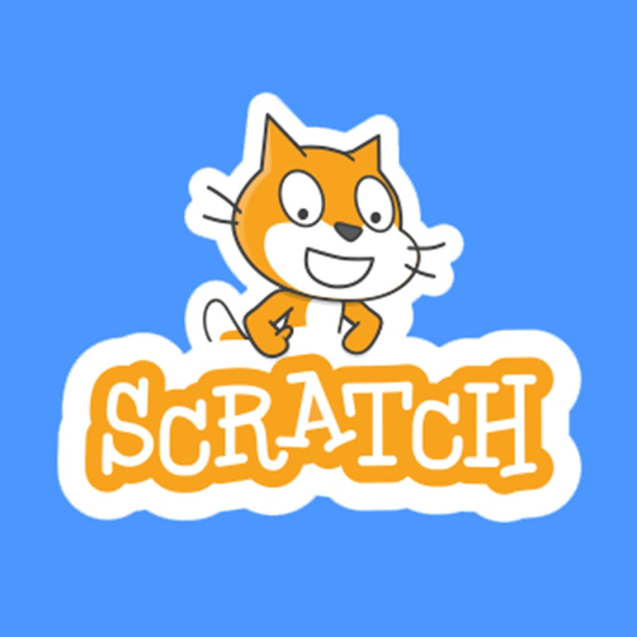**Digital Technology**

Computing this term will consist of coding through the app Scratch. The children will use coding to create a detailed 1 player game that includes heroes and villains. The children will design their own heroes and villains before using the graphics supplied to create a game.

**Modern Foreign Languages – MFL**

The children will continue to practice hearing and saying Spanish words and phrases through songs and rhymes as well as developing accurate pronunciation as they go.



**Religious Education – RE**

Within Religious Education, the children will be exploring the following key question over the course of the term:

* Is anything ever eternal?
* How did Jesus create a ‘New Covenant’ and what does that mean to Christians today?
* Is Christianity still a strong religion 2000 years after Jesus was on Earth?

**Home Learning**

* As we approach SATs, we will be organising **weekly homework** for all children which they will complete in SATs revision books. More information on this will follow once the books have been delivered to school.
* 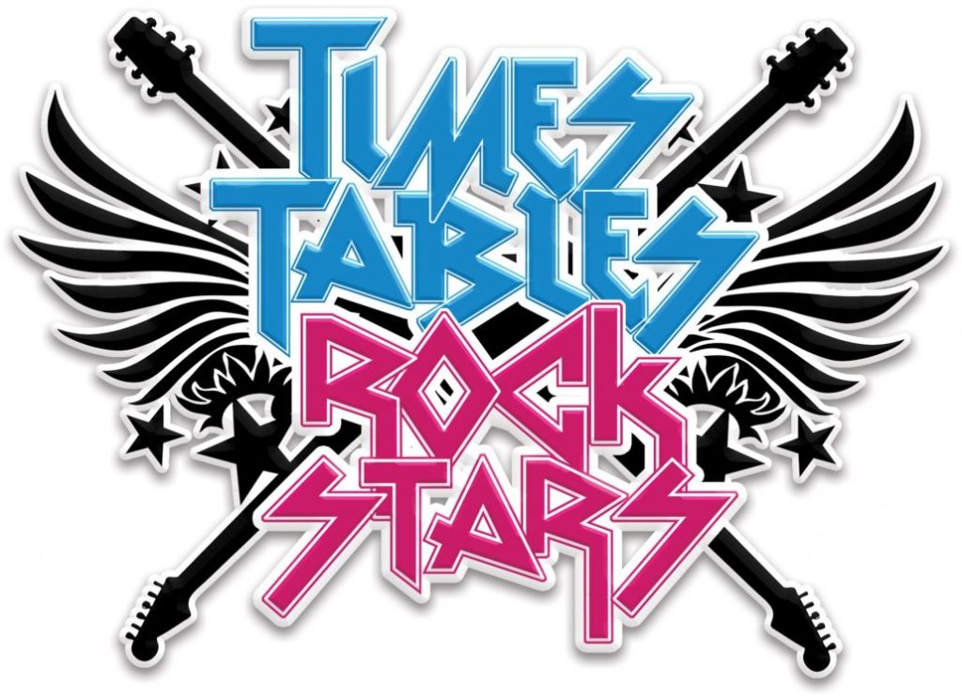Children are expected to be **reading** to an adult at least 3 times a week, and independently change their books on a regular basis, varying between home reading books and school library books to encourage a wider range of texts being read, whilst promoting a love of reading. Please log any reading in the reading diary and encourage your child to note any independent reading they do too.
* 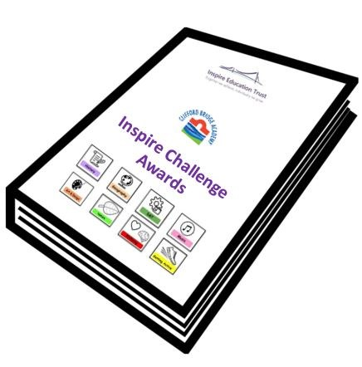**Times Tables Rockstars** is an excellent way for children to practise and consolidate their times table knowledge. The children will be set weekly battles against other classes and year groups in order to compete for rewards.
* In conjunction with the 50 Things to do before you are 11 ¾ by the National Trust, children have the opportunity to complete activities as part of the **Inspire Challenge Awards**. Once children complete a challenge, children will receive a sticker with the specific logo of the challenge to collect in their booklet. At the end of the year, if all challenges have been completed, children will receive their year group specific badge at a special award ceremony.

**Class Dojo**

Class Dojo is a communication platform to keep you informed of your children’s work as well as any key information that we need to share with you on a daily basis. Please ensure you keep up to date with messages posted out on Dojo as we use this as our daily means of communication. If you are having any difficulties accessing this, please let us know.

Many thanks for your continued support,

Miss Jaques and Mr Seath

Year 6 Team