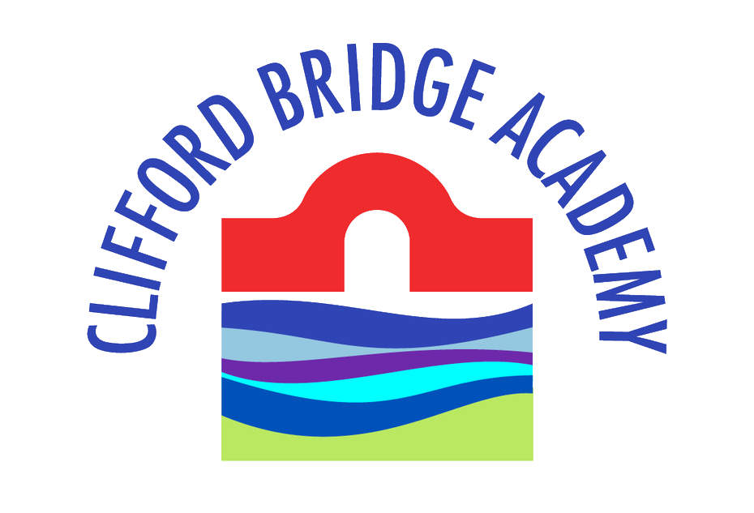

**Year 5 Curriculum Letter - Spring 2023**

Dear Parents & Carers,

Welcome back from the Year 5 Team! We hope that you and your family had an enjoyable Christmas and New Year. This letter is to keep you informed about some of the work that the children will be doing during the spring term.

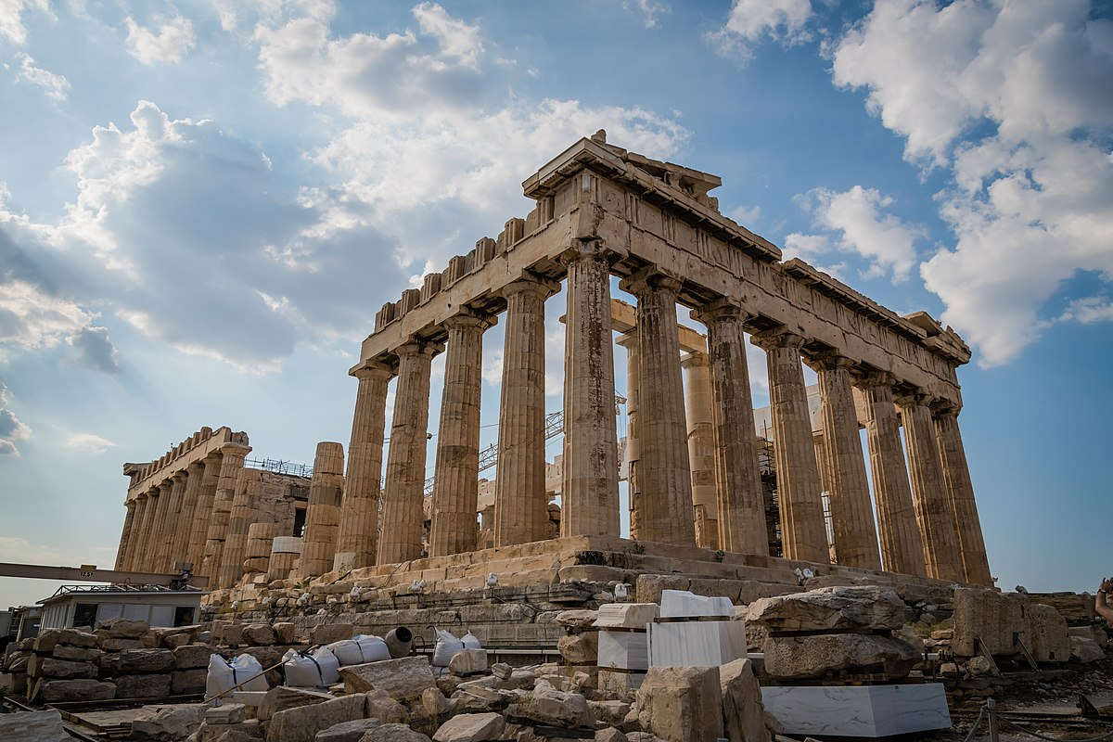**Theme – Greek Legacy**

This Term our topic is ‘Greek Legacy’. Within this theme, the children will be learning about Ancient Greece. They will be exploring artefacts and discover all about Ancient Greek art and culture, producing music for the Olympic Games using music technology, sculpting a Greek vase and sewing a Greek-inspired cushion with their own fabric printing design. We hope that the children are as excited about the theme as we are! Be sure to ask them about the topic as it progresses.

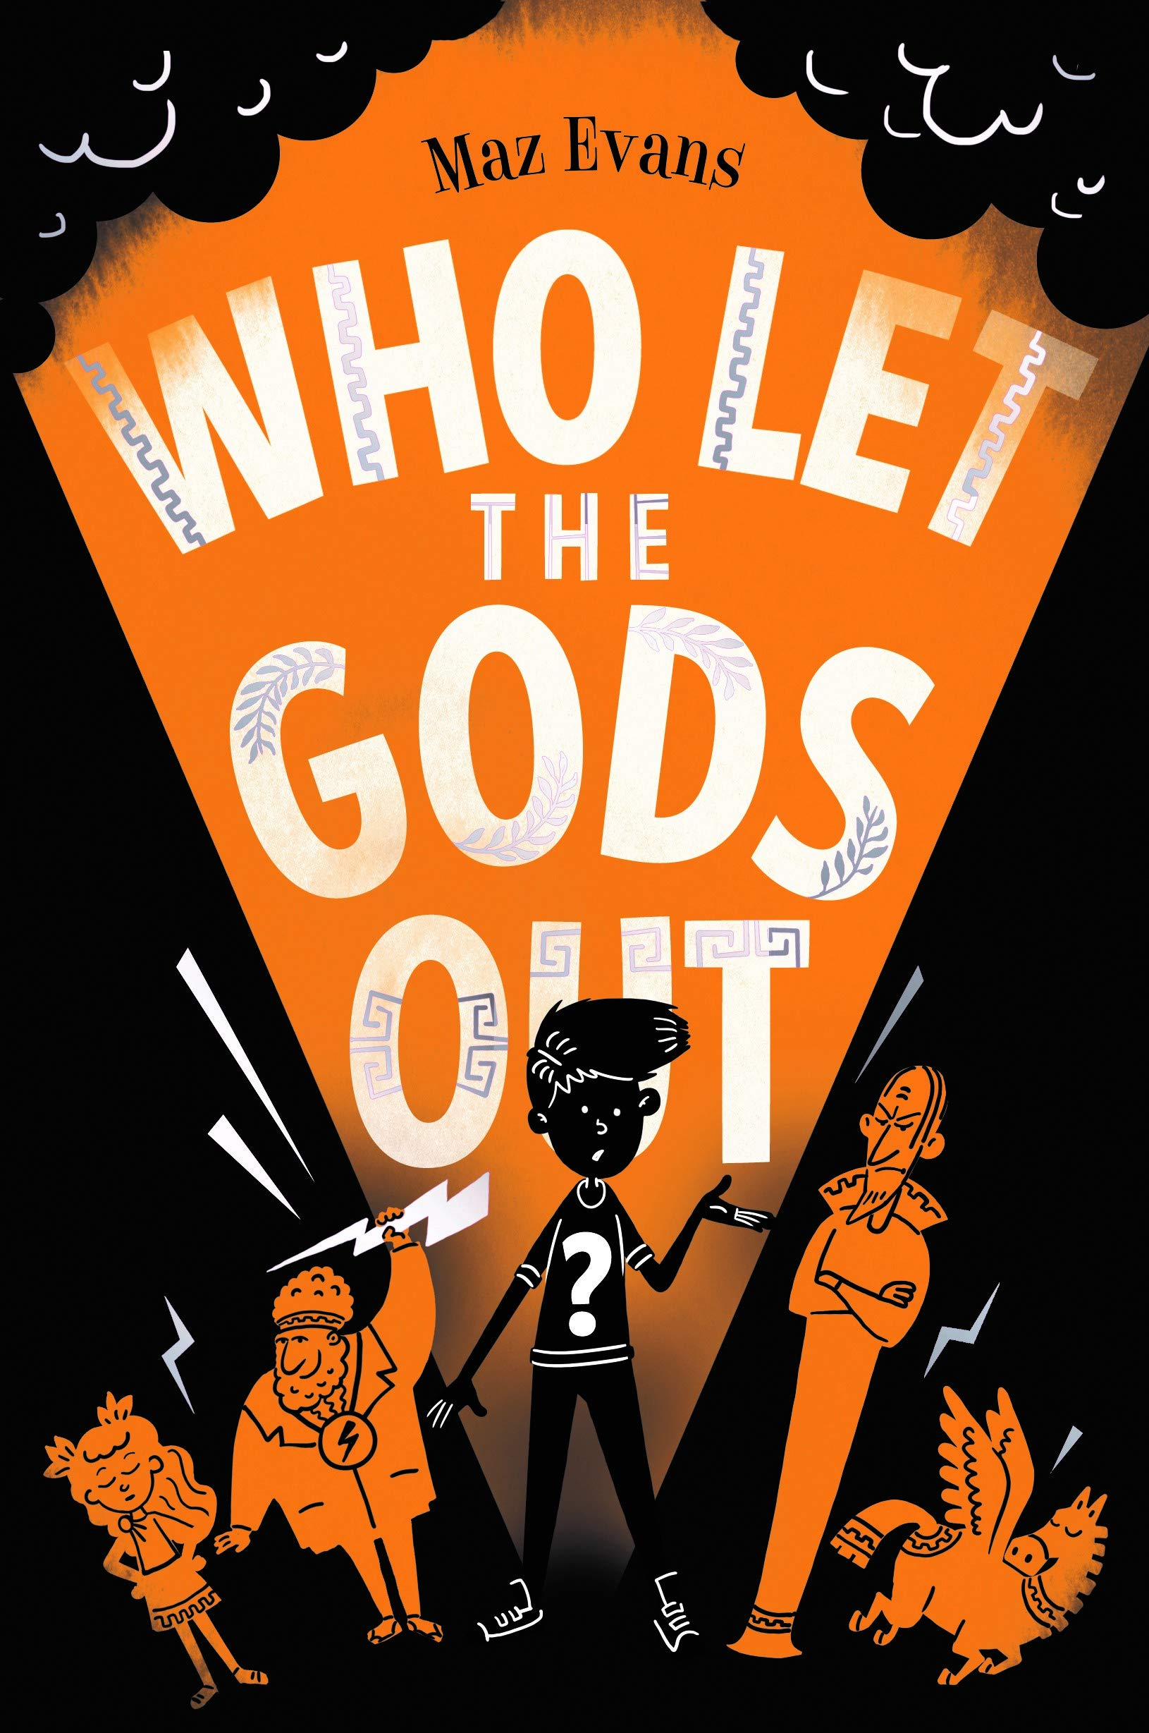**English**

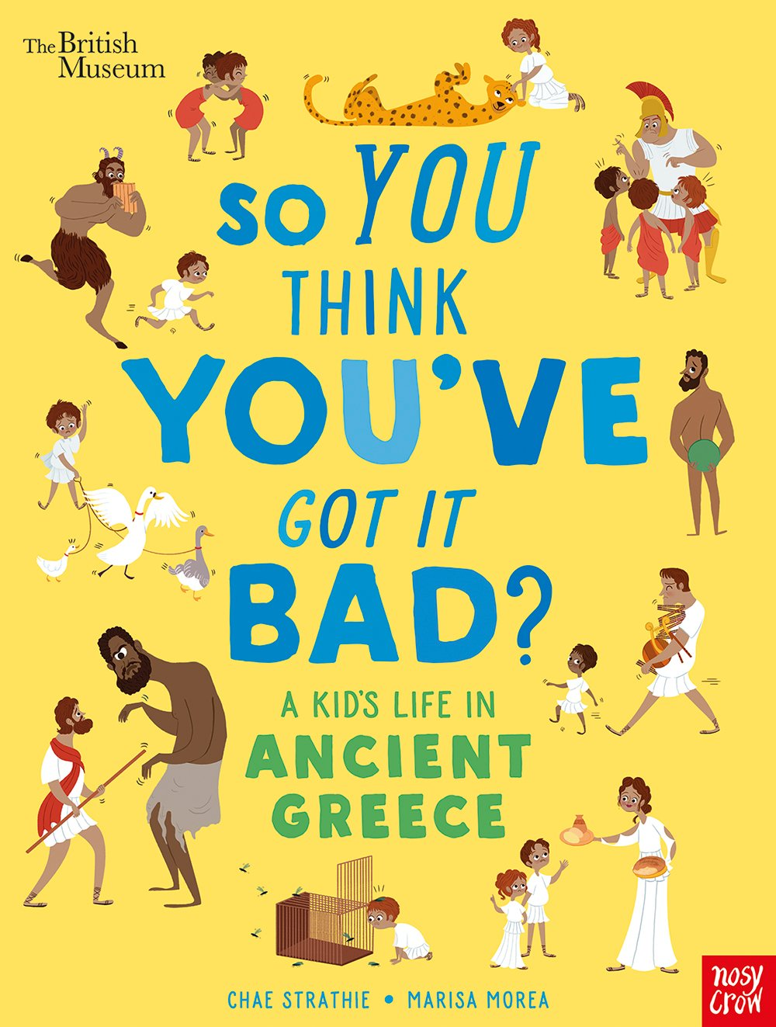During this term, the children will continue to engage with a range of fantastic narrative and poetic texts. They will continue to develop their reading skills, by inferring and deducing answers to questions about what they have read in greater depth. In their narrative work, children will be focusing on writing from different characters’ perspectives, using ‘Who let the Gods out?’ by Maz Evans as their text base. Aside from contemporary fiction, the children will be writing their own myth inspired by Theseus and the Minotaur as part of a Traditional Tales unit. Using their Theme knowledge, they will be focusing on developing their non-fiction skills and produce an information text all about daily life in Ancient Greece. Following on from this, they will interpret and complete work about the poem ‘Moon Juice’ by Kate Wakeling where they work on their performance poetry skills before producing their own poem in the style of Wakeling. The children will continue to write at greater length with increasing accuracy and appropriate detail across a variety of genres. Their understanding of grammar and punctuation will continue to develop as they build on their work from previous years.

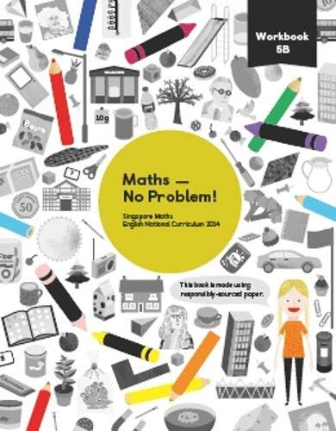**Mathematics**

During this term, the children will be focusing on securing their understanding of the four operations with a focus on multiplying by two-digit numbers, graphs, decimals, dividing using the bus stop method, measurement and fractions. During the first couple of weeks, the children will develop strategies to approach multiplication by two-digit numbers and division within and without remainders, before applying these skills to word problems. They will spend a large portion of this term looking at fractions. This will include learning about: improper fractions and mixed numbers; equivalent fractions; comparing and ordering fractions and finally investigating calculating with fractions. In this section, children will cover adding and subtracting fractions as well as multiplying fractions by whole numbers (always a great way to practise and consolidate our times tables knowledge). They will then move onto being able to read and write decimal numbers before moving on to adding and subtracting with decimals. We will also be using our weekly arithmetic sessions to recap on any prior learning such as times tables, addition and subtraction.

**Science**

This term in Year 5 Science, children will be covering the following units:

- **Danger Low Voltage**

During this topic, the children will learn all about electricity and how it is conducted or insulated. The children will compare and give reasons for variations in how components function, including the brightness of bulbs, the loudness of buzzers and the on/off position of switches. They will also use recognised symbols when representing a simple circuit in a diagram.

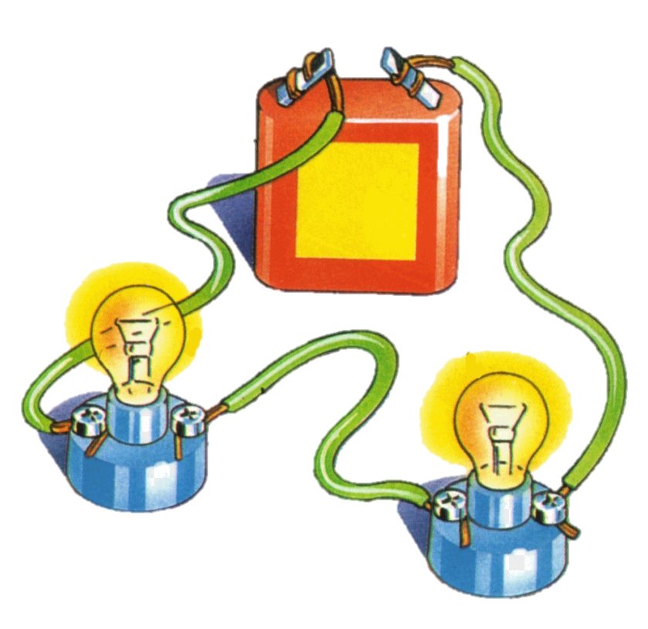- **Circle of Life**

During this topic, the children will learn all about the differences in the life cycles of a mammal, an amphibian, an insect and a bird. They will be able to compare these life cycles and identify the difference and similarities between them. The children will describe the life process of reproduction in some plants and animals. As part of this Science topic, they will investigate how to clone a potato by using their understanding of life cycles from the topic.

**Personal, Social and Health Education - PSHE**

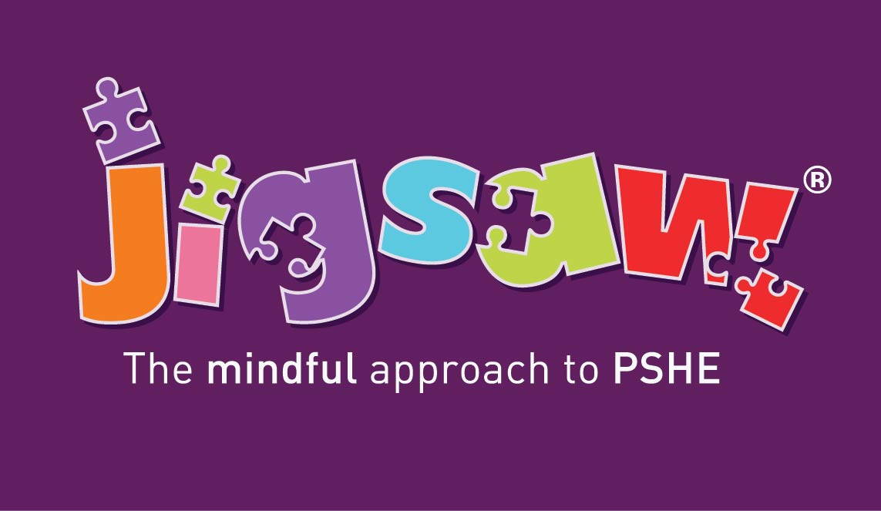Our Jigsaw themes this term are ‘Dreams and Goals’ and ‘Healthy Me’. Children will be thinking about: personal and academic goals and targets; aspirations and dreams for the future; the importance of living a healthy and active lifestyle, and body image and personal health. We will continue having weekly Thrive class assemblies, that will support the children’s emotional health, well-being and social skills. This allows the children to develop their voice in order to express their needs and feelings.

**Physical Education - PE**

In PE, we will be focusing on Football, Gymnastics, Dance and Tennis. These will take place on Tuesdays

(outdoor) and Wednesdays (indoor). Children should wear their PE kit to school on these days to maximise learning time. Just a reminder that children are required to wear a white t-shirt and dark coloured shorts, leggings or tracksuit bottoms. Children should have their red school jumper, cardigan or fleece over the top of their PE t-shirt. Earrings must be taken out or covered and as in school, long hair must be tied back. Please support this vital area of the curriculum by helping children to bring the correct changes of clothes to school for these sessions.

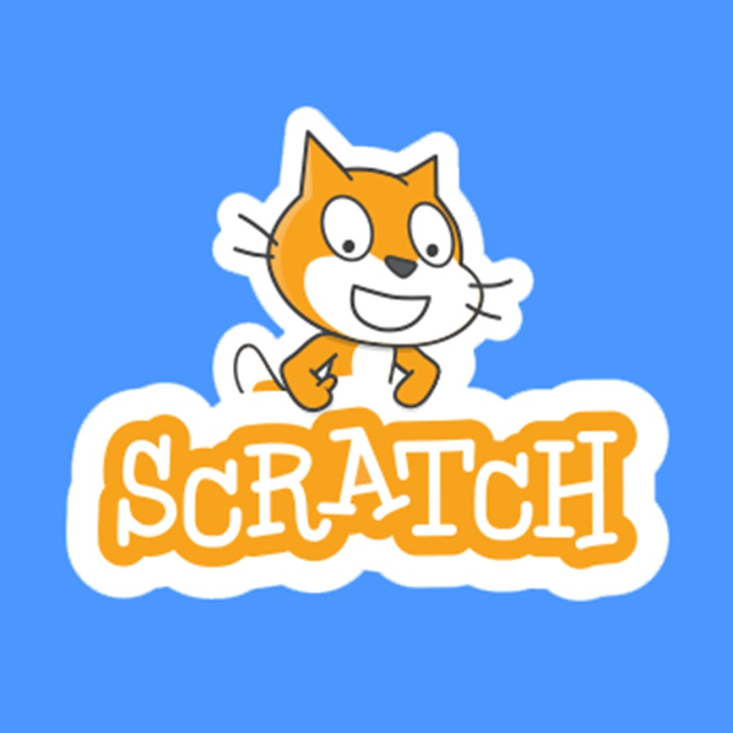

**Digital Technology**

Computing this term will consist of coding through the app Scratch. The children will use coding to create a detailed 2 player game that includes racing cars around a track. The children will design their own cars and use the graphics supplied to create a game.

**Modern Foreign Languages – MFL**

The children will continue to practice hearing and saying Spanish words and phrases through songs and rhymes as well as developing accurate pronunciation as they go.



**Religious Education – RE**

Within Religious Education, the children will be exploring the following key question over the course of the term:

* Are Sikh stories important today?
* How significant is it for Christians to believe that God intended Jesus to die?

**Home Learning**

• Children are expected to be reading to an adult at least 3 times a week, and independently change their books on a regular basis, varying between home reading books and school library books to encourage a wider range of texts being read, whilst promoting a love of reading. Please log any reading in the reading diary and encourage your child to note any independent reading they do too.

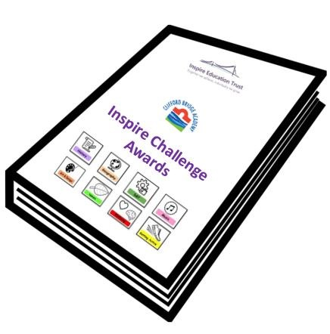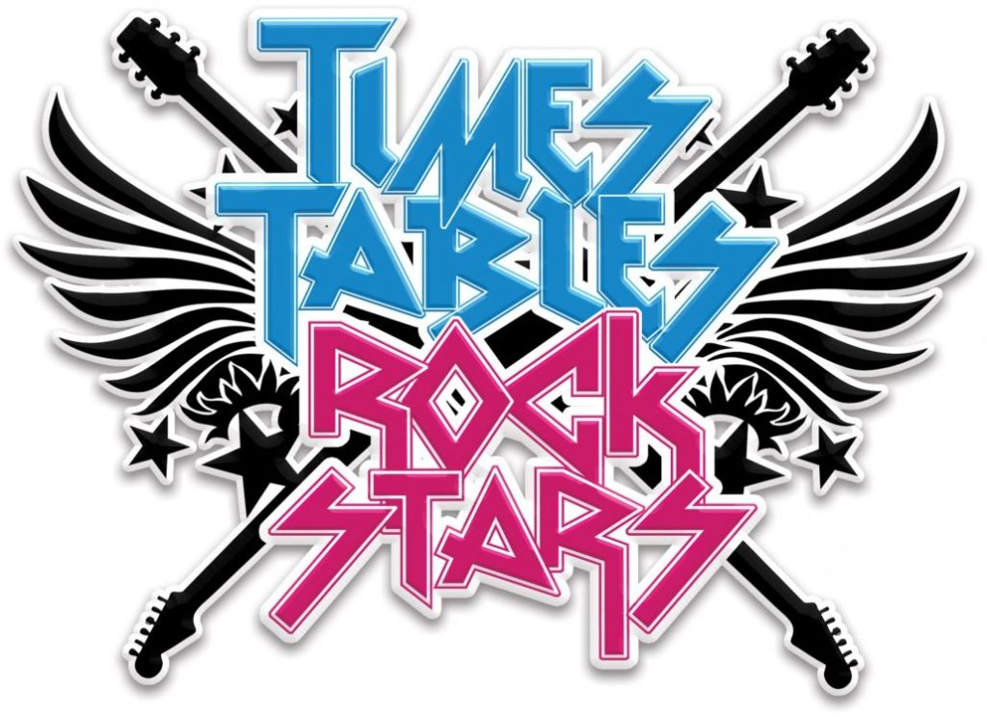• **Times Tables Rockstars** is an excellent way for children to practise and consolidate their times table knowledge. The children will be set weekly battles against other classes and year groups in order to compete for rewards.

* In conjunction with the 50 Things to do before you are 11 ¾ by the National Trust, children have the opportunity to complete activities as part of the **Inspire Challenge Awards**. Once children complete a challenge, children will receive a sticker with the specific logo of the challenge to collect in their booklet. At the end of the year, if all challenges have been completed, children will receive their year group specific badge at a special award ceremony.

**Class Dojo**

Class Dojo is a communication platform to keep you informed of your children’s work as well as any key information that we need to share with you on a daily basis. Please ensure you keep up to date with messages posted out on Dojo as we use this as our daily means of communication. If you are having any difficulties accessing this, please let us know.

Many thanks for your continued support,

Miss Every, Mrs Moore and Mrs Jonck

Year 5 Team